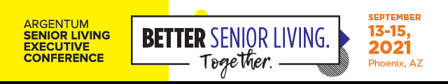
Dear [insert supervisor’s name],
I’m interested in attending the 2021 Argentum Senior Living Executive Conference & Expo (conference.argentum.org) from September 13-15 in Phoenix, AZ—the first major in-person senior living industry event in nearly two years. I believe it’s more important than ever to take this opportunity to hear the latest updates, explore new trends and solutions, connect with other like-minded professionals, prepare for the industry’s future, and bring back key takeaways that can improve the operations and business objectives at [insert company/community].
At this conference, I’ll be able to hear from thought leaders and changemakers inside and outside the senior living industry and will have the chance to network with peers all across the country who are experiencing similar challenges and opportunities. Plus, they’ve instituted an EventSafe program that prioritizes the health and safety of all attendees, so I’ll have the confidence to make the most of the experience knowing the environment is safe.
Here are just a few of the sessions and events I’d like to attend and why I believe their takeaways will be a value-add to [insert company/community] and my professional development:
- [Insert session/event name, description, and expected takeaways]
- [Insert session/event name, description, and expected takeaways]
- [Insert session/event name, description, and expected takeaways]
- [Insert session/event name, description, and expected takeaways]
Below, I’ve outlined some of the approximate costs to attend the conference. If I register by August 9, I can save by taking advantage of the discounted Early Bird rate!
- Registration: $ [insert your registration cost]
- Travel: $ [insert your travel cost for airfare, rental car, etc.]
- Hotel: $ [insert your accommodations cost]
- Meals: $ [insert your approximate costs for food & drink]
TOTAL: $ [insert total cost]
I believe attending this event will provide a tremendous benefit to [insert company/community] as I’ll be able to bring back new ideas to help improve operations and build a professional network I can call on for leveraging ideas and actions. Thanks for your consideration.
[insert signature]

